Lab: Gaining Experience with GitLab, Junit and EclEmma

### Required:

Internet Connection

Eclipse IDE for **Enterprise Java Developers** (can download here: <https://www.eclipse.org/downloads/packages/>) See the accompanying Lab video.

This is a multi-part lab that you can complete in sections, over time. Each section is a predecessor to the next. Fill in the answers to questions posed throughout the lab.

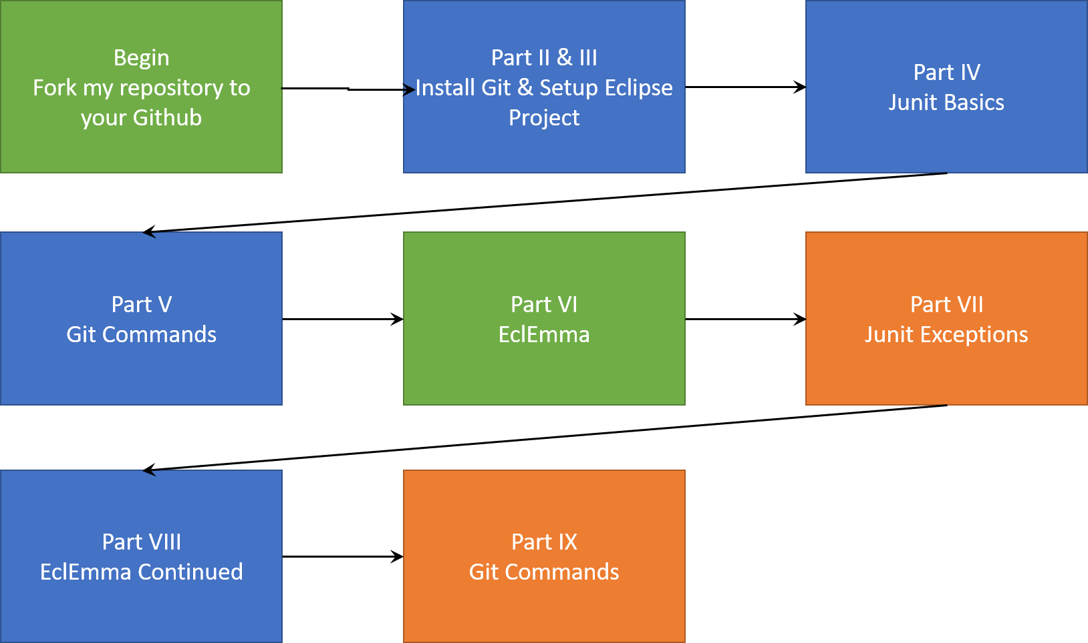

# Overview of this Lab

### Instructions:

**Part I: Fork the Git Repository**

For this lab, you will use github.com. CSUS also has gitlab.ecs.csus.edu. If you do not have an account, create one on github.com

1. Login to your account and goto:

Github.com: <https://github.com/azizijonespenn2/JUnitLab_Begin.git>

1. Fork the repository: This will create a copy of it in your own account location.

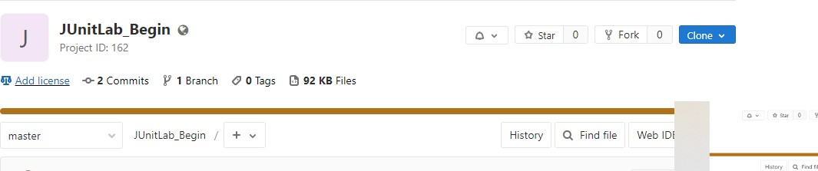

### Part II: Introduction to Git

* 1. Download Git from <https://git-scm.com/downloads>
  2. Install Git on your local machine. Accept the defaults. Make sure you add Git to your path so that you will be able to execute git commands from the prompt.

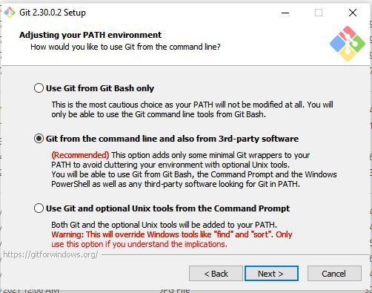

* 1. Open Windows CMD prompt or Windows Powershell.
  2. Choose or create a directory to house your local repository. Navigate to this directory.
  3. Clone **your** remote repository. In this example, the student is Aliyah Penn (aliyahpenn)

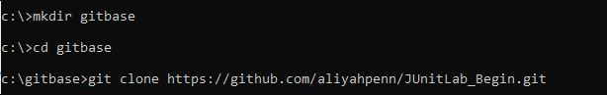

* 1. Now that you have cloned your remote repo to your local repo, proceed with the Junit Test portion of the lab.

### Part III: Creating a Java Project using the Cloned Repository

1. In *Package Explorer*, create a *New* → *Java Project*. Name the new project in the next screen. Uncheck the option “*Use default location*” since you will use the location of your local Git repository. Then, (click) *Browse* and locate the folder that houses your local repository e.g. *git* → *JUnitLab_Begin*. Click *OK* → Click *finish*. You will see a new java project that appears in the *Package Explorer*, named *JUnitLab_Begin*.

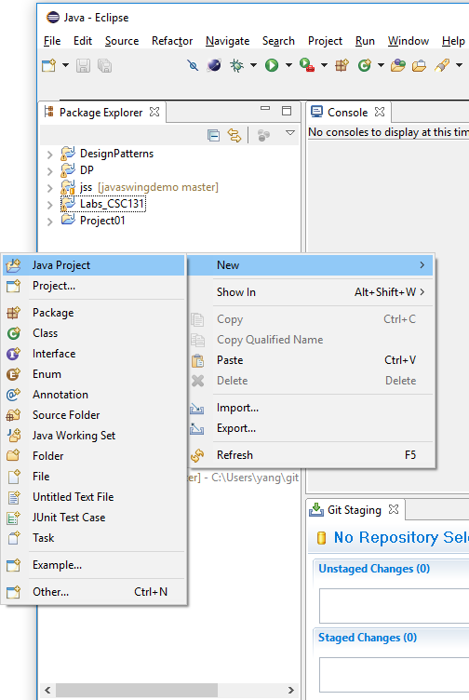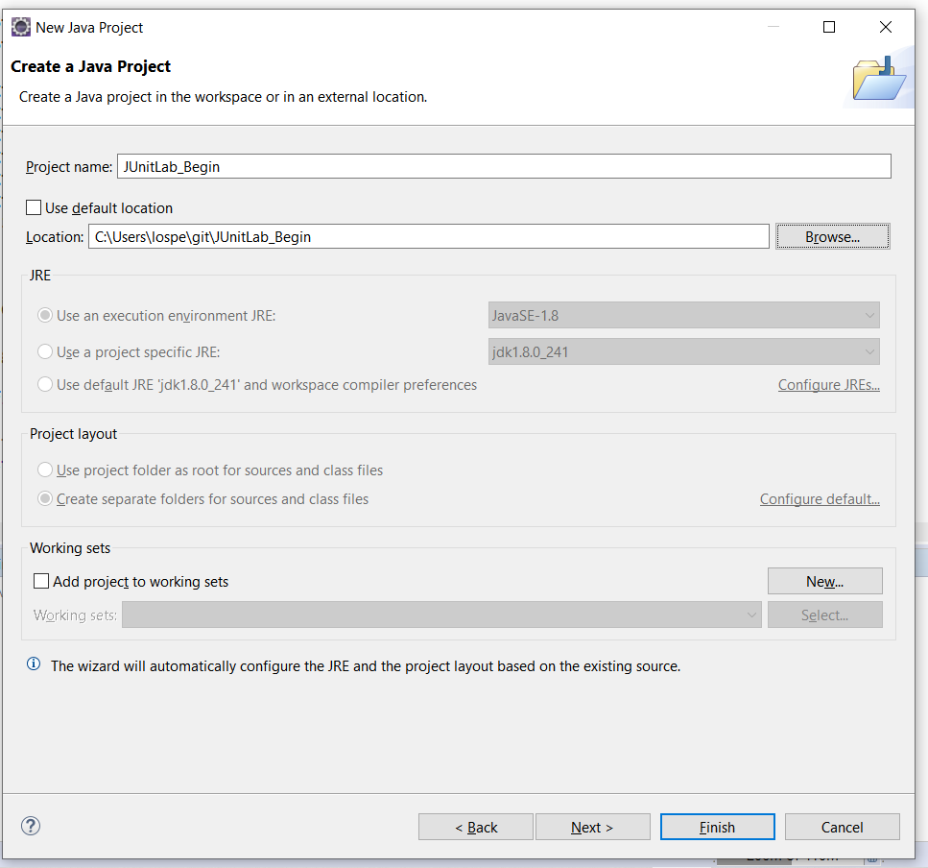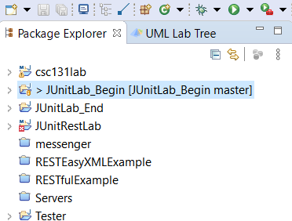

* 1. New Java Project, 2. Use the local Git repository as the project location 3. Project appears in your package explorer.

**Part IV: Junit Basics**.

***JUnit Basics:*** JUnit is an open-source testing framework. It provides a way to write, organize, and run repeatable tests. This part of the lab will help you become familiar with JUnit. [If you do not already have the code from the Git lab exercises, clone the repository located at: <https://github.com/azizijonespenn2/JUnitLab_Begin.git>to get the source code for this lab]

* + 1. Create an empty JUnit test named GiftCardTest in the csc131.junit package by clicking on:
       - File->New->Other->Java->Junit->JUnitTestCase.
    2. Use the Junit4 version.
    3. Click Browse for the Class under test: field and start typing in the GiftCard.java. When the class is found, select it and click OK.;Then click Finish. If necessary, add JUnit to the build path when asked.

Note: Normally, you should put tests in their own package(s). To keep things simple, we will break that rule.

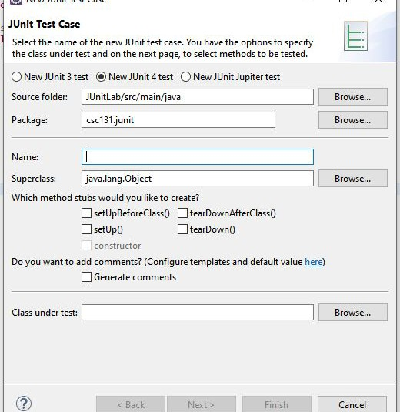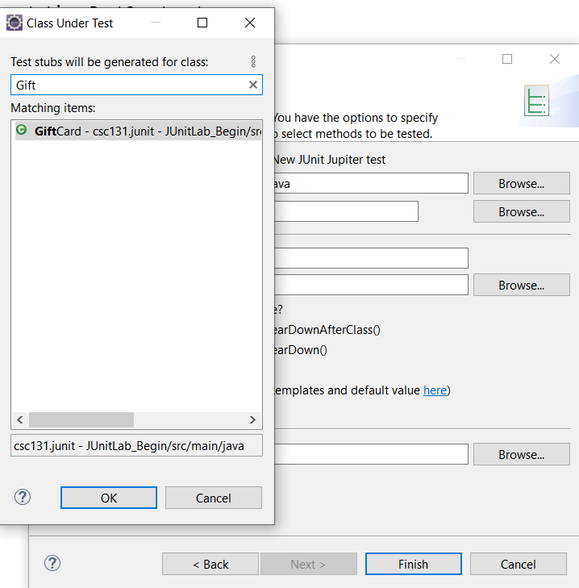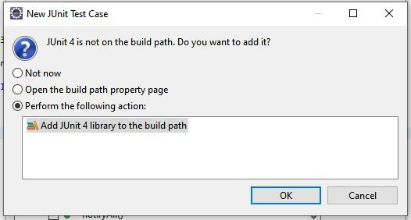

* + 1. Type the following code into GiftCardTest.

import static org.junit.Assert.assertEquals; import org.junit.Test;

import org.junit.rules.ExpectedException;

public class GiftCardTest

{

@Test

public void getIssuingStore()

{

double balance;

GiftCard card;

int issuingStore;

issuingStore = 1337;

balance = 100.00;

card = new GiftCard(issuingStore, balance);

assertEquals("getIssuingStore()",

issuingStore, card.getIssuingStore());

}

}

* + 1. A JUnit test suite is a class, much like any other class. Tests are methods that are preceded with the annotation @Test. (Note: An annotation provides information about a program but is not part of the program. Annotations have no effect on the operation of the program. Instead, they are used to provide information to tools that might use the program as input.)

How many tests are in the test suite GiftCardTest?

One test, getIssuingStore()

* + 1. JUnit has an Assertclass that has a static assertEquals()method with the following signature that is used to compare expected and actual results:

public static void assertEquals(String description, int expected, int actual)

where description is a human-readable String describing the test, expected is the expected result, and actual is the result of actually running the code being tested.

How would you call this method and pass it the String"getIssuingStore()", the int issuingStore, and the int returned by the cardobject's getIssuingStore()method?

Assert.assertEquals("getIssuingStore()",issuingStore, card.getIssuingStore());

* + 1. How is this method actually being called in GiftCardTest?

assertEquals("getIssuingStore()",issuingStore, card.getIssuingStore());

* + 1. Why isn't the class name needed?

Because we import "import static org.junit.Assert.assertEquals;”, it's static modifier and it can seem to be a class we declared. Then, the compiler can understand that the name class can be reduced when we declared static method before.

* + 1. Execute GiftCardTest. (Right Click on the File in Project Explorer and select Run As->Junit Test

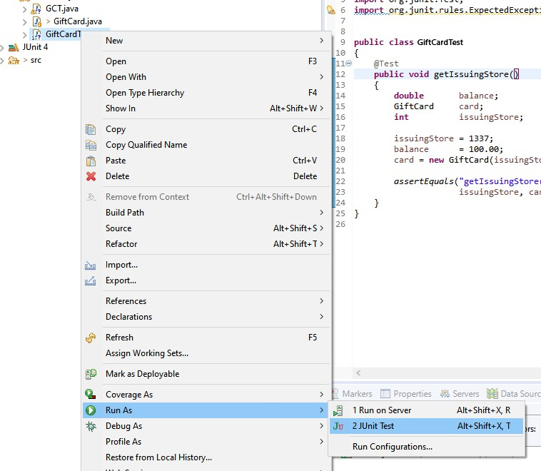

* + 1. What output was generated?

Nothing, but we can see the test results in a new window. It shows us a test suite and if our code

passed or not.

* + 1. To see what happens when a test fails, modify the getIssuingStore() method in the GiftCard class so that it returns issuingStore + 1, compile GiftCard.java, and re-run the test suite.

Now what happens?

The test fails

* + 1. In the "Failure Trace", interpret the line:

java.lang.AssertionError: getIssuingStore() expected:<1337> but was:<1338>

## Note: You may have to scroll the "Failure Trace" window to the right to see the whole message.

The test "getIssuingStore()" was run, but the expected value is 1337 not 1338

* + 1. What mechanism is JUnit using to indicate an abnormal return?

It's throwing an exception

* + 1. Before you forget, correct the fault in the getIssuingStore() method.
    2. The Assert class in JUnit also has a static assertEquals() method with the following signature:

public static void assertEquals(String description, double expected, double actual, double tolerance)

where tolerance determines how close to double values have to be in order to be considered "approximately equal".

Add a test named getBalance() that includes a call to assertEquals() that can be used to test the getBalance() method in the card class (with a tolerance of 0.001).

* + 1. How many tests are in your test suite now?

2

* + 1. Suppose you had put both calls to assertEquals() in one method (named, say, getIssuingStore()). How many tests would be in your test suite?

Only one test. Suppose we put both calls to assertEquals(), we just check different cases in one method

* + 1. Re-compile and re-execute the test suite. How many tests were run?

2, both of them passed

* + 1. The Assert class in JUnit also has a static assertEquals() method with the following signature:

public static void assertEquals(String description, String expected, String actual)

Using JUnit terminology, add a test named deduct_RemainingBalance() to your test suite that can be used to test the deduct() method in the GiftCard class. Note: Be careful, the variables that are declared in the getIssuingStore() method are local. Copy and paste the code for the deduct test here:

*@Test*

public void deduct_RemainingBalance()

{

double balance;

GiftCard card;

int issuingStore;

String s;

issuingStore = 1337;

balance = 100.00;

card = new GiftCard(issuingStore, balance);

s = "Remaining Balance: " + String.*format*("%6.2f", 90.0);

*assertEquals*("deduct(10.00)", s, card.deduct(10.0));

}

### Part V: Git Commit, Push,

1. You now have a new file, GiftCardTest.java to commit to your repository. You need to mark it to be staged to your local repository.
2. Open a Command Prompt or Powershell and navigate to your project’s directory.
3. Type “git status” to see what state the files are in. You should see GitCardTest.java listed as an untracked file.

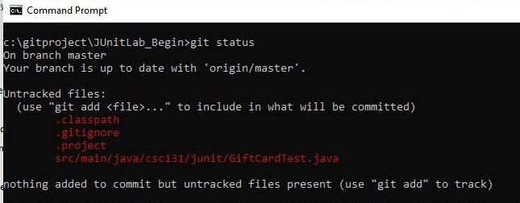

1. Execute “git add <filename>” to stage your file(s). Then run “git status” again to see what happened.

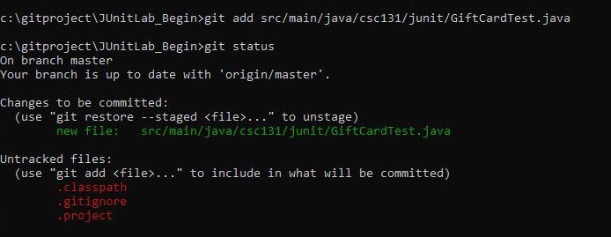

1. Now Commit the File to your local repository by typing “git commit”. What happens when you execute this command?

*** Please tell me who you are.

Run

git config --global user.email "you@example.com"

git config --global user.name "Your Name"

to set your account's default identity.

Omit --global to set the identity only in this repository.

fatal: unable to auto-detect email address (got 'ptanh@MSI.(none)')

Add a commit message to describe your changes. Depending on your OS, Git may utilize a VIM type editor for you to enter your commit message.

1. Push the changes to your remote repository
2. You probably still have a few files that are marked as untracked. Some are local files specific to your Eclipse installation. These files should not be pushed to a shared repository since other developers will have different settings. Since you don’t wish to commit these files AND don’t want them to continue to show up as untracked, what do you need to do to have Git ignore them?

I need to use “.gitignore” command to ignore files I don’t need.

### Part VI: EclEmma

This part of the lab will help you understand coverage tools and coverage metrics.

* 1. Read Eclipse_Eclemma.pdf.
  2. Run GiftCardTest using EclEmma, click on the "Coverage" tab and expand the directories/packages until you can see GiftCard.java and GiftCardTest.java.



Test are executed

## How many of the tests passed?

3

* 1. Does this mean that the GiftCard class is correct?

Yes

* 1. What is the statement coverage for GiftCard.java?

73.4%. I think 3 tests were passed. It should be 100%.

* 1. What do you think it means when a statement is highlighted in red?

Even though tests were executed, some statements were not covered.

* 1. Hover your mouse over the icon to the left of the first if statement in the constructor. What information appears?

1 of 2 branches missed.

* 1. Add tests to your test suite so that it covers all of the statements and branches in the deduct() method in the GiftCard class.

@Test

public void deduct_AmountDue()

{

double balance;

GiftCard card;

int issuingStore;

String s;

issuingStore = 1337;

balance = 100.00;

card = new GiftCard(issuingStore, balance);

s = "Amount Due: " + String.format("%6.2f", 10.0);

assertEquals("deduct 110 from 100", s, card.deduct(110.0));

}

@Test

public void deduct_InvalidTransaction()

{

double balance;

GiftCard card;

int issuingStore;

String s;

issuingStore = 1337;

balance = 100.00;

card = new GiftCard(issuingStore, balance);

s = "Invalid Transaction";

assertEquals("deduct -10.00 from 100", s, card.deduct(-10.0));

}

* 1. Your test suite still does not cover every statement in the GiftCard class. What is different about the statements that remain untested?

Those statements are in exception.

### Part VII: Junit Exceptions

***Testing Methods that Throw Exceptions:*** This part of the lab will help you learn how to test methods that throw exceptions.

JUnit has an Assertionsclass that has a static assertThrows()method with the following signature that is used to test expected exceptions. The signature is:

public static <T extends Throwable> T assertThrows(Class<T> expectedType, Executable executable)

1. Create another @Test annotated method and add the following code to it’s body:

assertThrows(IllegalArgumentException.class, () -> {new GiftCard(1,-100.00);});

Note: IllegalArgumentException is an unchecked exception. Hence, the code will compile even if it isn't re-thrown. If you are testing for a checked exception then the method must specify the exception.

@Test

public void constructor_IncorrectID_Low()

{

assertThrows(IllegalArgumentException.class, () -> {new GiftCard(-1, 9999);});

}

1. Add a test to your test suite named constructor_IncorrectID_Low() that covers the case when the storeID is less than 0.

*@Test*

public void constructor_IncorrectID_Low()

{

*assertThrows*(IllegalArgumentException.class, () -> {new GiftCard(-1, 9999);});

}

# Part VIII: EclEmma Continued

***Coverage and Completeness***: This part of the lab will help you better understand code coverage and the completeness of test suites.

1. Run EclEmma on your current test suite. What is the statement coverage for GiftCard.java now?

100%

1. What branch does the test suite fail to test?

The test suite is covering StoreID < 0 and StoreID > MAX_ID

1. Add a test to your test suite named constructor_IncorrectID_High() that covers the other branch.

@Test

public void constructor_IncorrectID_High()

{

assertThrows(IllegalArgumentException.class, () -> {new GiftCard(100000, 100.00);});

}

1. Run EclEmma. What is the branch coverage now?

All branches are covered now

# Part IX: Git

## Commit your changes to your local and push to your remote repository using the process you’ve already done.

1. Now, create a pull request. Go to your Github account.
2. Click Pull Request

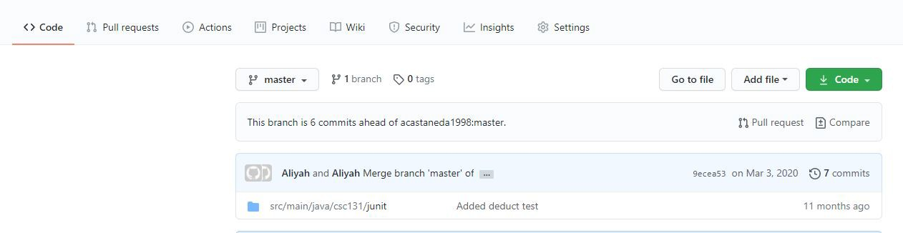

1. Create a new pull request